**Electric Circuit**

This section deals with the electric circuit and circuit components that we will use.

**Requirements**

As we are going to control the temperature of bicycle so we require both heating and cooling components. Since heating components will operate when environment temperature is very cold and user wants to increase the bicycle temperature. Cooling components will do its working when environment temperature is too hot and user wants to cool down the bicycle temperature.

We will use paltier material as heating component because it is semiconductor heat pump so it best suits our requirement but its efficiency is very low. Since paltier can also work as cooling component by just reversing the direction of current but due to its very low efficiency (about 5%) we will use ni-chrome wire as heating component.

To allow the user to interact with the temperature maintaining system it is natural to have a user interface. Our user interface will consist of a LCD and push buttons.

For the bicycle’s self-ability to generate enough power to keep running the system it’s important to use dynamo (generator) as power source. Since paltier use high power and requires high current for its proper operation we will not only use solar cell but also use electricity to keep the batteries charged. Hence rechargeable batteries are another requirement.

To control the whole system, we require a microprocessor. This microprocessor will take the user input and will make the output as per the instructions.

**Selected Components as Required**

Since once we have made all of our requirements, now next step is to decide which component among its family would suit the best. Hence we have selected following components:

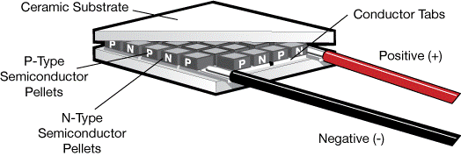**Paltier**

Paltier has following properties:

* Thermoelectric materials
* Seebeck effect (converting temperature to current)
* Peltier effect (converting current to temperature)

We will use paltier material at three different locations: saddle, left side of handle, right side of handle

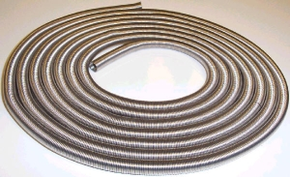**Heating Coil:**

Due to very low efficiency of paltier heating wire is optimal solution. We will use ni-chrome wire for heating purposes.

**Power Amplifiers**

Since paltier requires high power which microcontroller cannot provide so there is a need to amplify the power. There are many power amplifiers commercially available but they are expensive. So cost effective solution is to make your own power amplifier.

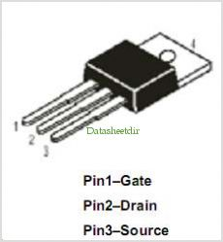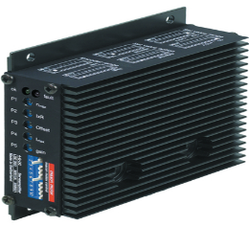

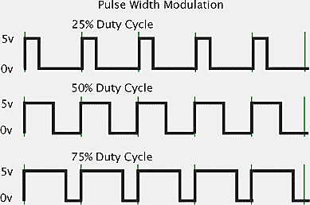We will control paltier material and heating coil using PWM modulated signal.

**Arduino Microcontroller**

Arduino microcontroller not only reads the user’s input via push buttons, displays output on LCD but also controls the bicycle temperature.

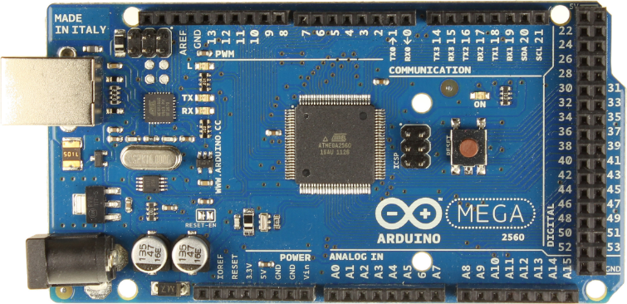

**LCD**

A 20x4 LCD we have decided to use for visual feedback to the user.

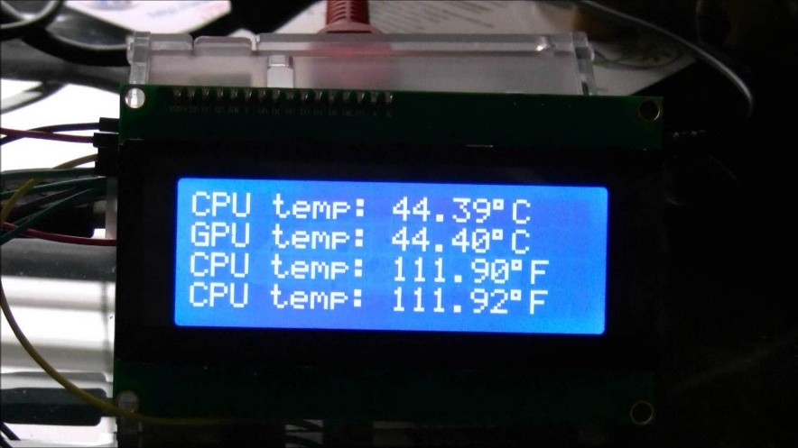

**Battery**

High current portable rechargeable battery is the requirement to make the system work properly and efficiently.

**Solar Cell and Dynamo (Generator)**

Renewable energy sources are the requirement for supplying enough power to the system. As we have decided so far, we will use two 6W solar cells and four 6W dynamos.

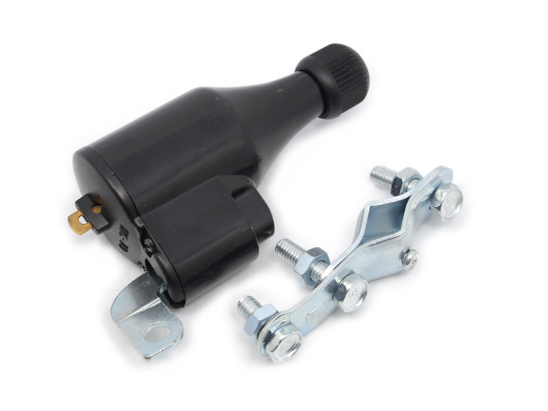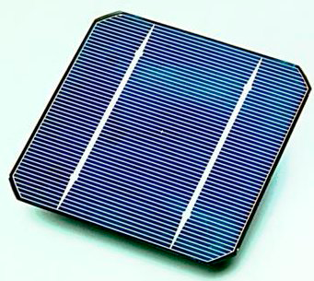

**System flow diagram**

The following figure briefly describes the interaction of all devices with microcontroller.

